Practice: Drone Mission Plan
This exercise will introduce you how to use a drone planning software to plan a mission. Basically, with this planed mission, the drone could fly in a systematic way, such as having a same altitude, speed, tilt, and so on. It could also launch and return to home point automatically. Such planning could help to consistently monitor your area of interests and save much time during the field work. There are many kinds of mission planning software. In this exercise, you will learn how to use DJI Gound Station (GS) Pro, as it works best with DJI drones.

Step 1. Install DJI GS Pro
- DJI GS Pro can be easily found on Apple store. In the Apple store winddown, type in ‘GJI GS Pro’, it should be shown up. Download and install it. Note, DJI is only available for iPad. If you have your own iPad, please install it. Otherwise, you can use Dr. He’s research group iPad, which already has the GS Pro installed.
- Click on the GS Pro App, log in with you DJI account. Note, if you have created an account for DJI Go 4 App, the account should be same for GS Pro. Otherwise, you need to create an account.
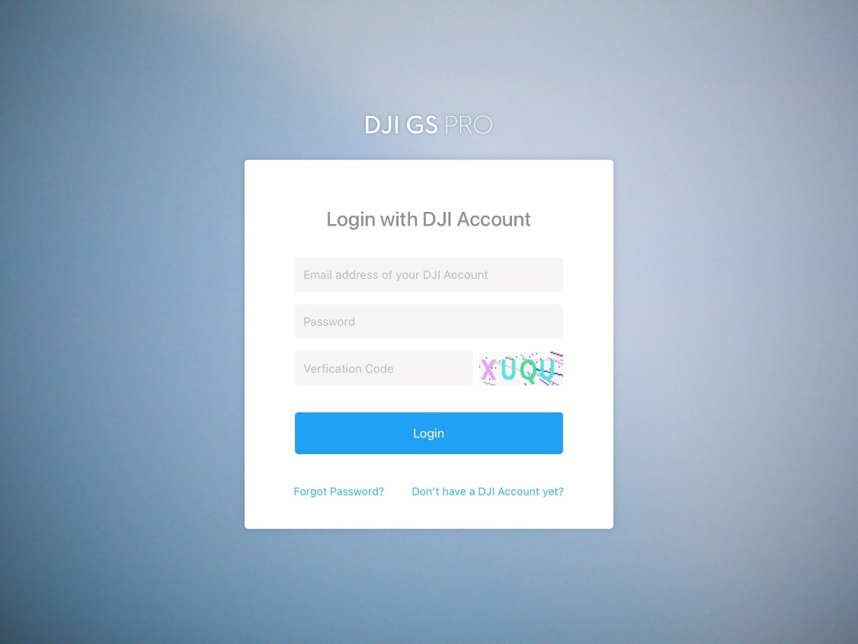

Step 2. Plan drone mission
- Click on the My mission and plus icon, at lower-left corn.
- The New Mission window should be shown. You can see there are several different mission types.
  - PhotoMap is a 2D mission. The user can import photos directly into DJI GS Pro and a photomap can be composited automatically in the app, providing a reference for information for other missions. However, each account only comes with five free trials, after that it requires a purchase.
  - Virtual Fence defines a specific area of light and is useful in scenarios where some areas of a site are no-fly zones.
  - 3D Map is a 3D mission. The image data captured during theses flights can be input into 3D reconstruction software to generate 3D maps.
  - 3D Map POI is similar as 3D Map. However, it gathers critical data from physical structures. It requires purchasing to performance the mission, although creating and editing is permitted.
  - Waypoint flight sets a waypoint flight path.
- Click on 3DMap Area, followed by Tap. It will enable you creating a mission with the background image.
- It will zoom into your current location. Our study will be the practice field beside the Jewel Moore Nature Reserve.
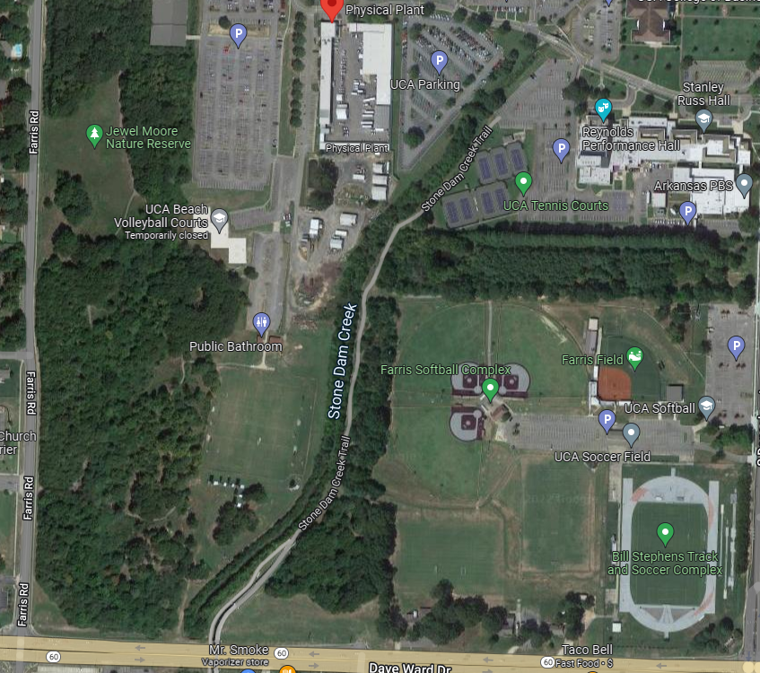
- Navigate to the location. Note, it does not enable a search location function. You must find the practice field by yourself.
- Make the Practice Field at the center of the screen. Tap it, a rectangle show be shown. Enlarge the rectangle to cover the entire Practice Field. It is better to cover ~10% more areas surrounding the Practice Field.

- In the left Mission Panel, select Phantom 4 Pro V2 Camera for Camera Model, as it is our drone camera.
- Set Course Aligned for Shooting Angle, Capture at Equal Dist. Interval to Capture Mode, Inside Mode to Flight Course Mode. These setting basically will tell the drone how to fly over the study area and how to take pictures.
- Set 200 feet for flying height. You will notice the speed will be changed. The Waypoints Quantity, flight length, Course Count, Flight Time, Photos numbers, and approximate number of batteries in the top panel will also be changed.
- 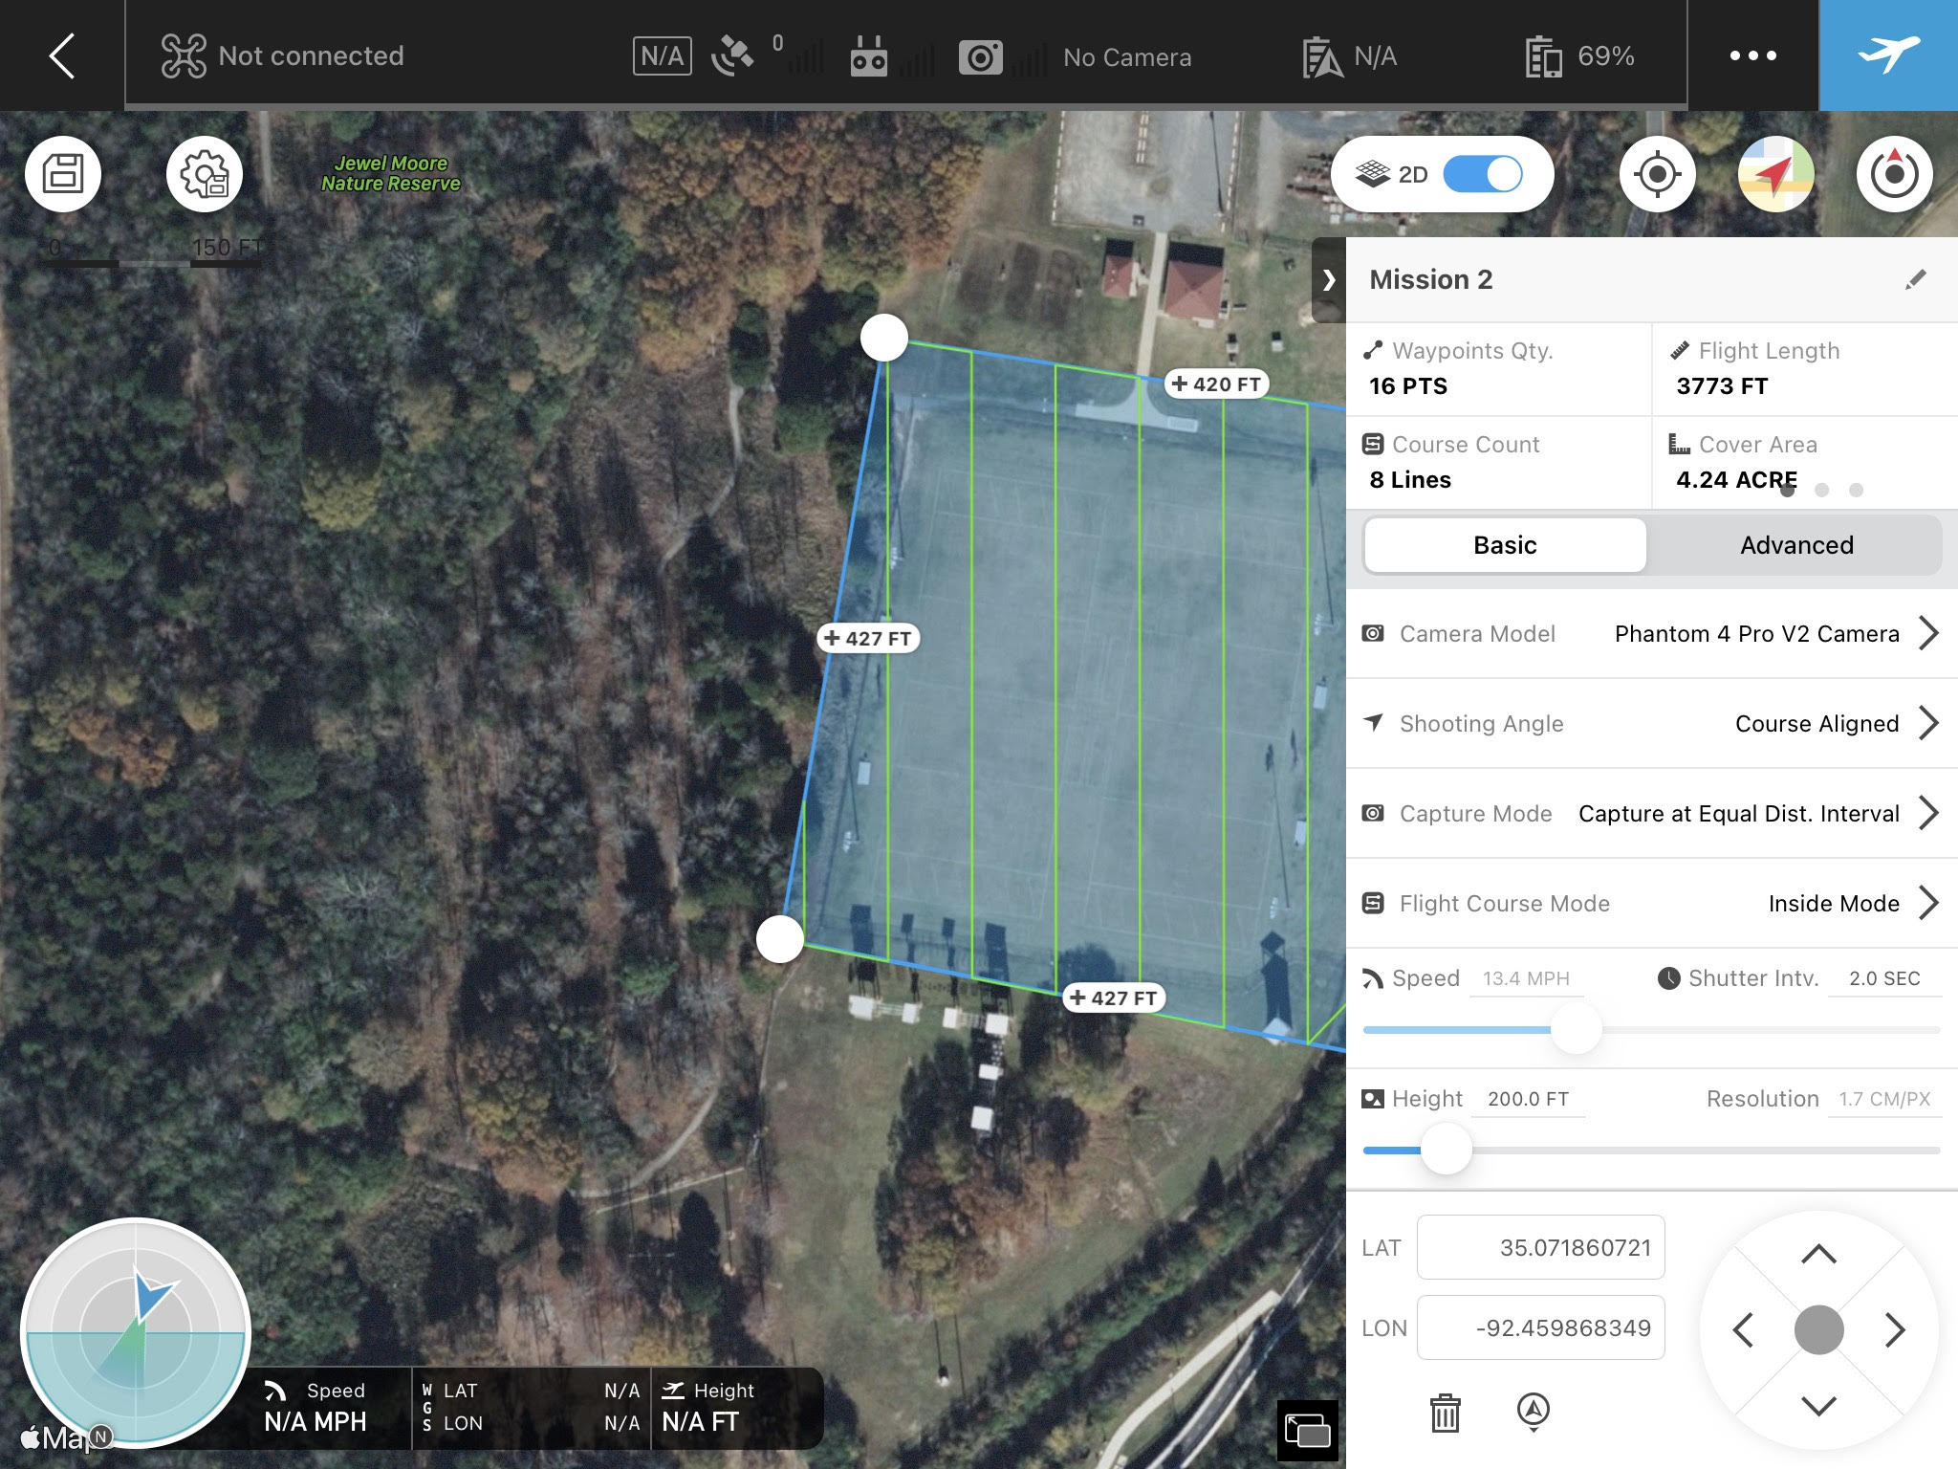

- Click on Advanced, set 80% for both Front Overlap Ration and Side Overlap Ratio. Again, the flight time, number of photos etc. will be changed.

- Set 90 degree to Course Angle. Play attention to the green lines in the left map. You should see the orientation of lines will be changed. You will use your preferred angles.
- Set 0 feet to Margin to cover the entire study area
- Set -90 degree to Gimbal Pitch Angle to make sure Gimble take the pictures at the nadir direction.
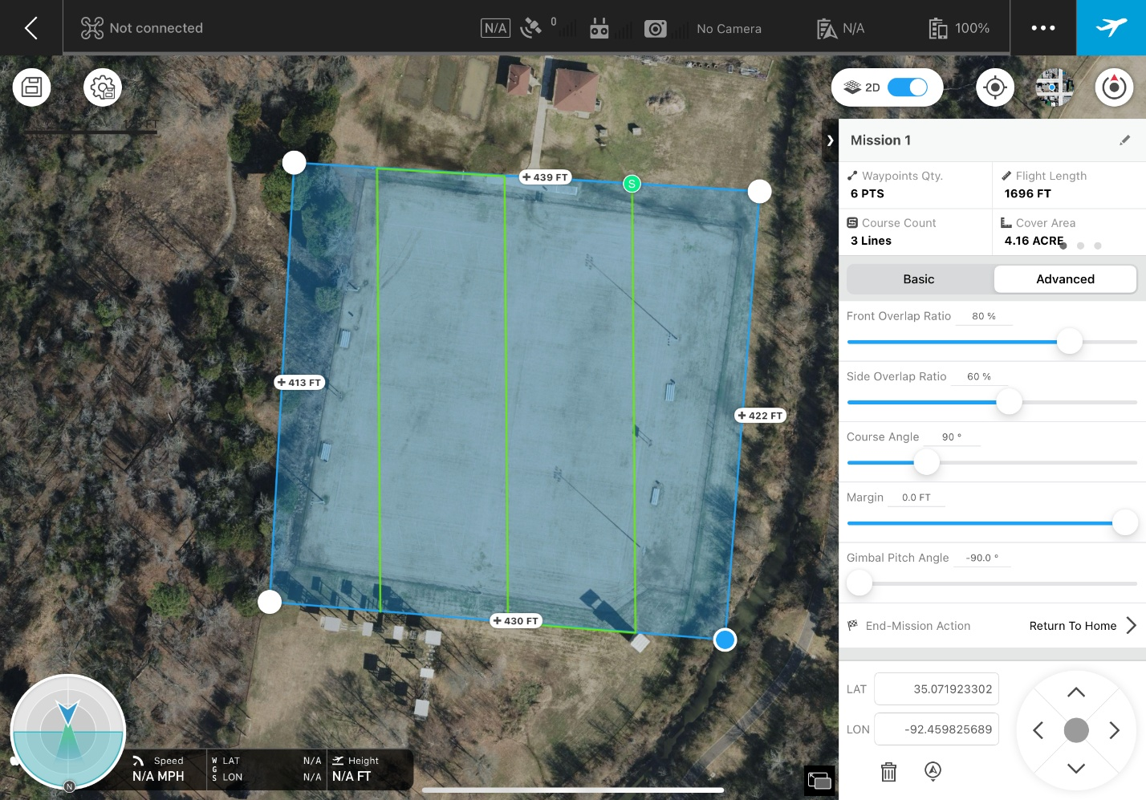
- Click on Save icon at top-right corner. Your mission should be saved.
- Back to your home page, you should see your mission.
- Click on it, you should see the settings that you just planned.

